Lexical Semantic Change (LSC) (also known as Semantic Shift Detection).

Embedding types:
- Static - treat a word as a single entry no matter where it appears, embedding stays same. Cannot handle polysemy
- Contextual embeddings - like BERT or GPT. Uses context vectors for clues.
- Temporal embeddings - used for diachronic analysis. Instead of just looking at the sentence, the model is conditioned on a timestamp. (TimeLMs, DiachronicBERT)

Metric type:
- Geometry-based (cosine, Wasserstein)
- Distribution-based (entropy, JS divergence)
- Temporal asymmetry (event-aware)
- Predictive / causal proxies
We ignore static for now - reasons why
https://docs.google.com/spreadsheets/d/1MA2fKw2bUstxvfay1pj9NjA1wIze2AfRE-5-OfzDldQ/edit?usp=sharing

2024 survey:
https://dl.acm.org/doi/full/10.1145/3672393
Problem statement formulation
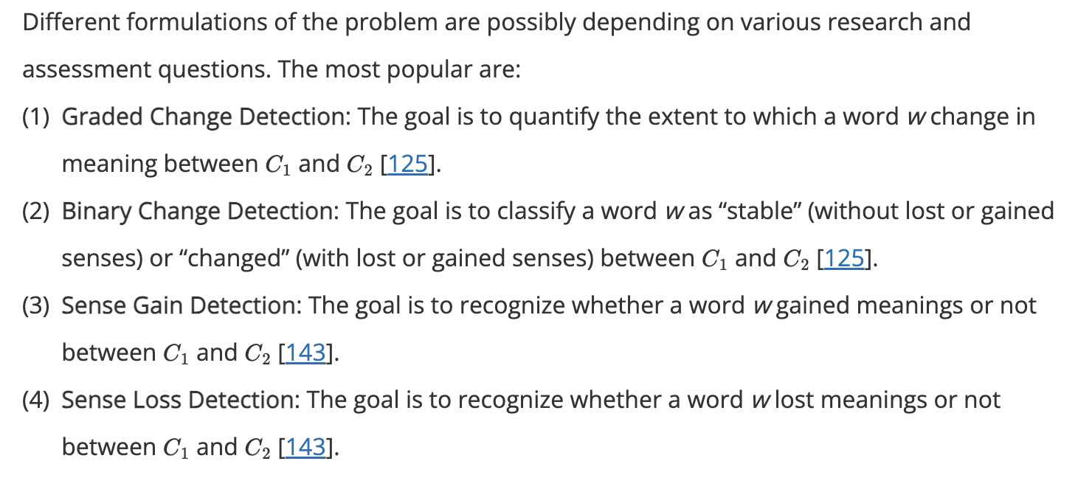
LSC
Worklow:
- generate a semantic representation for each word occurrence (all forms)
- OptionalLY, AGGREGATE (clustering or averaging)
Different types of representations can be used. Possible options are:
word embeddings: a semantic vector in a multi-dimensional space that is directly generated by the Encoder of LLMs, such as BERT, RoBERTa, or ELMo
lexical substitutes: a bag of words that is generated by a Masked LLM such as BERT and RoBERTa to substitute a specific occurrence of w in a document. For example, suitable substitutes for the word fly in the sentence a noisy fly sat on my shoulder are bug, beetle, or butterfly; while suitable substitutes in the sentence we will fly to London are walk, run, or bike
sense definitions: a descriptive interpretation that is generated by a Causal LLM to represent the occurrence of the word w in a particular document. Alternatively, when available, lexical resources like WordNet can be used.

Currently, contextualized word embeddings are the most widespread tool in LSC

See the function in that paper

Indeed, even if a word does not gain/lose meanings (i.e., “stable” word), it can be associated with a high value of s due to other forms of semantic change, such as amelioration (change to positive connotation) and pejoration (change to negative connotation). However, in practice, Binary Change Detection is derived from Graded Change Detection by binarizing the graded s through a threshold

DIMENSION 1: MEANING REPRESENTATION
1. Form-Based
This approach treats a word as a single entity, focusing on its overall dominant meaning. It takes all the different ways a word is used and collapses (averages) them into a single "word prototype.” It assumes the most frequent usage (the dominant sense) will define the vector.
2. Sense-Based
This approach treats a word as a collection of different "senses" or usages. Clustering instead of averaging. It captures competition and cooperation. You can see a "minor" meaning (like "Amazon" as a store) slowly gaining ground and eventually overtaking the "major" meaning (the river).

Dimension 2: Time awareness. This dimension focuses on how the time information of the documents is considered by the employed LLM.
1. Time-Oblivious (Inferred Context)
These models assume that language itself provides enough clues to reveal the time period. They rely entirely on the contextual nature of embeddings.
2. Time-Aware (Explicit Labeling)
These models are built on the belief that a "snapshot" model (trained on the internet in 2021, for example) cannot truly understand or generalize to other time periods without help.
it is needed that the LLM is aware of the time in which a document is inserted in the corpus. As a result, a time-aware LLM encodes the time information as well as the linguistic context of a document while generating the word representations.

Learning modality. This dimension is about the possible use of external knowledge for describing and learning the word meanings to recognize.
supervised: A form of supervision is enforced to inject external knowledge to support the change assessment. In addition to the text in the corpora c1and c2, a lexicographic/manual supervision is employed. Lexicographic supervision refers to the use of dictionaries, vocabularies, or thesauri to support word sense induction and recognize the meaning of each word occurrence.
unsupervised: The change assessment is exclusively based on the text of the corpora , without any external knowledge support.

Some metrics:
Form based:
- Cosine distance (averages over all uses at time t1, and all at t2). Can be made time aware
- Time-Diff - If a word's meaning is stable, it appears in similar linguistic contexts across all years. If its meaning shifts, the contexts around it become so unique to a specific era that an AI can guess the year just by looking at the sentence. D outperforms CD in short-term semantic change when their performance is compared on the task of Graded Change Detection across various benchmarks. On the contrary, CD outperforms TD over long-term semantic change.
- Average pairwise distance (APD). This measure exploits the variance of the contextualized representations , to compute the semantic change assessment (i.e., variance on the word polysemy). As a difference with the previous measures, APD directly works on word embeddings without requiring any aggregation stage, namely, clustering nor averaging. Masked LLM (lexical subs used)
- Hausdorff distance - HD relies on the Euclidean distance d to measure the difference between the embeddings of w in and , and it returns the greatest of all the distances d from one embedding to the closest embedding or vice versa.
- Difference between token embedding diversities (DIV)
Sense-based
all the sense-based approaches are time-oblivious and that fine-tuning is sometimes adopted, but mainly for domain-adaptation purposes. Most papers leverage unsupervised learning modalities. Only a few exceptions employ a lexicographic supervision
- Maximum novelty score
- Aximum square
- JSD
- Coeff of semantic change
- Entropy difference
- Cosine distance between semantic prototypes (PDIS)
- Difference between prototype embedding diversities (PDIV)
Ensemble based

- Form-based approaches dominate LSC research because:
  - They are simpler
  - They align well with benchmark evaluation setups
- Sense-based approaches are less common but theoretically richer, since they aim to model which meaning changed, not just how much.
Models & embeddings
- Almost all recent work uses contextualized embeddings from BERT-like models.
- BERT and XLM-R are the most popular; RoBERTa and ELMo appear less often.
- Surprisingly, ELMo often outperforms BERT in LSC while being:
  - Faster
  - Smaller
  - Less noisy
- Larger models ≠ better results.
Some tiny models (BERT-tiny, ELMo) perform best when paired with time-aware methods.
Training & fine-tuning
- Most methods are unsupervised.
- Domain-adaptive fine-tuning consistently improves results, but:
  - Too many epochs lead to overfitting
  - Effectiveness depends heavily on corpus size & domain
- Incremental or task-specific fine-tuning is still rare but promising.
Time-awareness
- Most approaches are time-oblivious
- Time-aware approaches consistently achieve top results on several benchmarks.
Sense modeling (clustering)
- Sense-based methods rely on clustering contextual embeddings.
- Common algorithms: K-means, Affinity Propagation, DBSCAN, HDBSCAN.
- Major issue: clusters often capture usage variation, not true lexicographic senses.
- Small clusters are often treated as noise, but this risks discarding genuine minor senses
Metrics
- Form-based: APD, CD, PRT are generally best-performing.
- Sense-based: JSD is popular but harder to aggregate into a single score.
- No single metric dominates across all languages and datasets.
Performance & evaluation
- No approach wins universally. They are language, dataset, and distribution dependent.
- Ensemble methods (combining embeddings + grammar or multiple metrics) often outperform single approaches.
- Benchmarks mostly cover 1–2 time periods, limiting long-term semantic analysis.

Gaps

